**BT 307 Lab 02**

1. Harsh Arora
2. 200106034
3. data1.csv

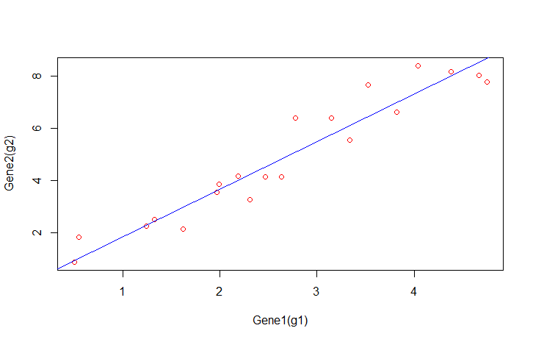

1. g2= (1.8266) g1
2. R-squared value=0.9845
3. p-value for slope(m)=2e-16
4. Statistical Value for y=mx+c model:-

Coefficients:

Estimate Std. Error t value Pr(>|t|)

(Intercept) 0.1078 0.3733 0.289 0.776

x 1.7934 0.1269 14.136 3.46e-1

Staistical Values for y=mx model:-

Coefficients:

Estimate Std. Error t value Pr(>|t|)

x 1.82660 0.05262 34.71 <2e-16 ***

we reject y=mx+c and accept y=mx because from the statistical test we can see that p-value for intercept is 0.776 which is much larger than 0.05. Hence we can say that we have accepted the null hypothesis of alpha=0 because its p-value is 2e-16 which is much less than 0.05.